**ENERGY AND ENERGETICS**

Chemical reactions involve

1. Bond breaking and
2. Bond forming

Energy changes are involved in these steps

**Note: Energy must be supplied to break bonds. Energy is released when bonds are formed.**

**Types of energy change in chemical reactions**

**Exothermic change**

This results in an increase in the temperature of surroundings that is heat is given off from the reaction (it feels hot). This is because more energy is released when new bonds are formed than when old bonds are broken.

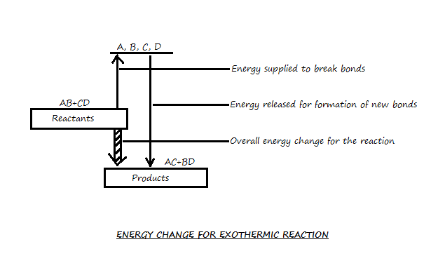

**Endothermic change**

Endothermic changes result in a fall of the temperature of the surroundings. These types of energy changes are very rare. For example, dissolving ammonium nitrate, sodium thiosulphate in water.

**Note: The reaction feels cold**

If more energy is supplied to break old bonds than is released when new bonds are formed, then it results in endothermic changes.

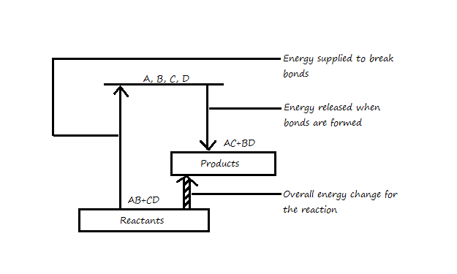

**Energy and Energy Profile Diagrams**

The chemical energy which a system produces is its enthalpy. Enthalpy is indicated by “H”, so the enthalpy or energy change for any reaction. If Hp<Hr, then ∆H is negative and the reaction is exothermic. If Hp>Hr, then ∆H is positive and the reaction is endothermic.

∆H = Hproducts-Hreactants

∆H = Hp-Hr

The following are energy profile diagrams for

1. Exothermic reactions

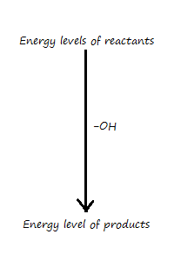

1. Endothermic reactions

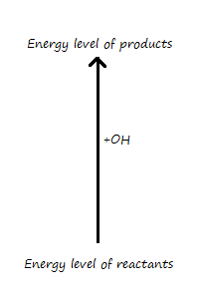

The minimum energy which must be supplied to break old bonds before reaction proceeds is known as activation energy of the reaction.

For a given mass of reacting substances, the heat released or absorbed can be calculated using the following relationship.

H = mass x specific heat capacity x change in temperature

H = mc∆T

Unit: Joule